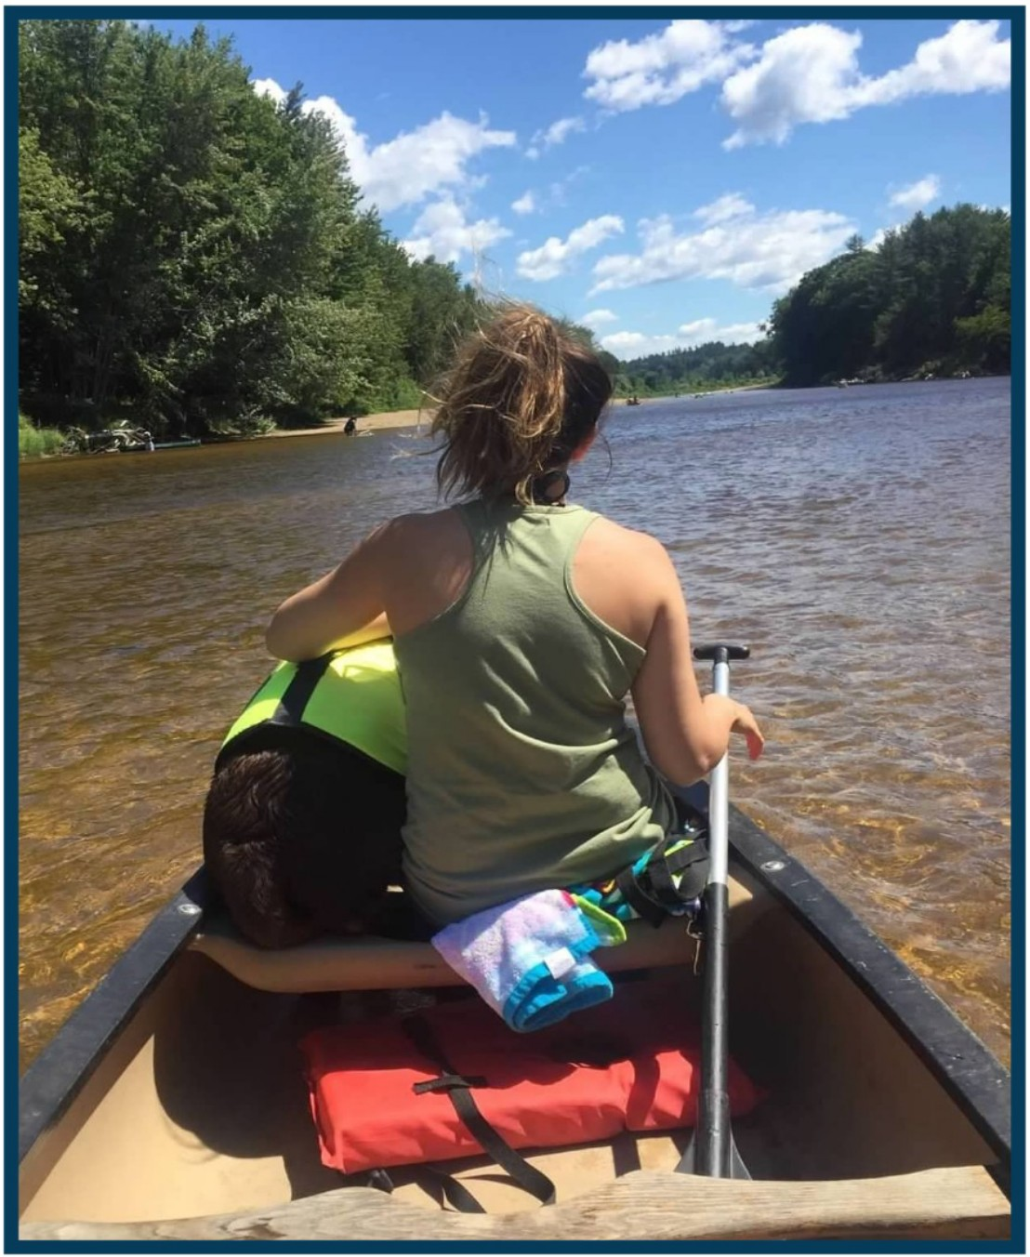

find your right path

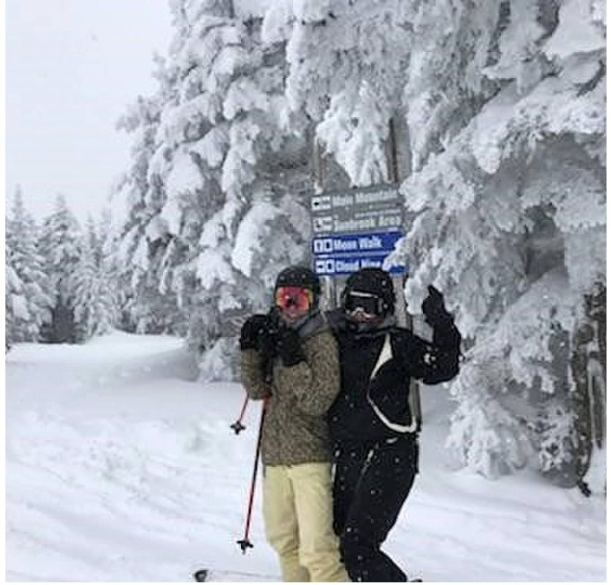

WILDCAT MOUNTAIN, NEW HAMPSHIRE

structured sober living in clinton, connecticut

right path for women

trauma sensitive structure
- what a day looks like
- location and amenities
- clinical promise
- recovery coaches
11 whole person - mind
- whole person - body
- whole person - soul
16 admission

18 tour-see your room

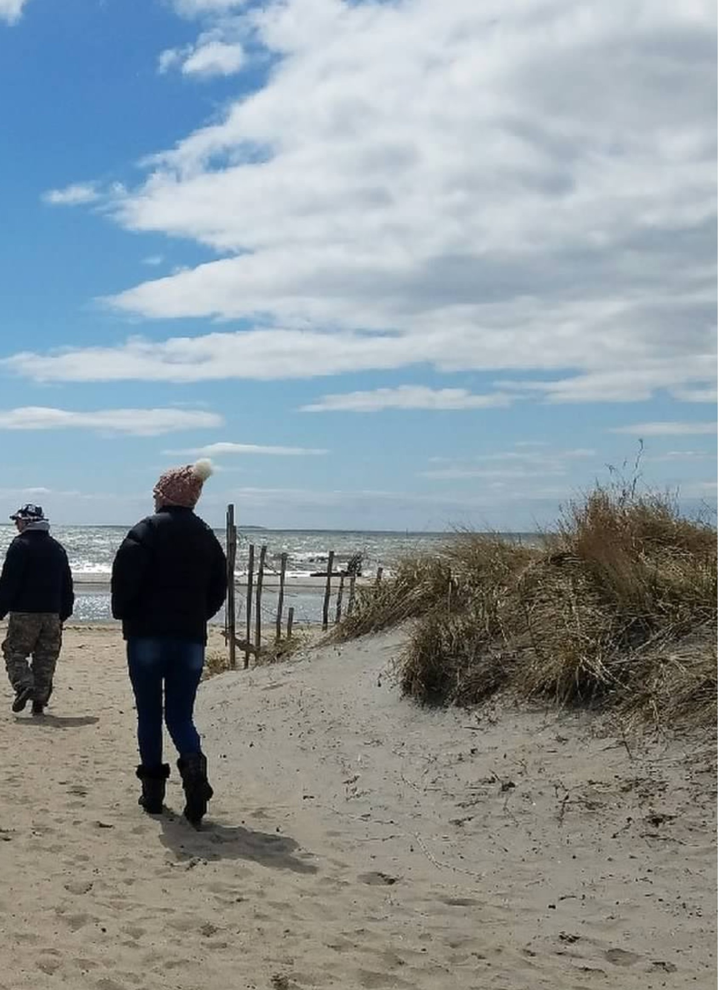

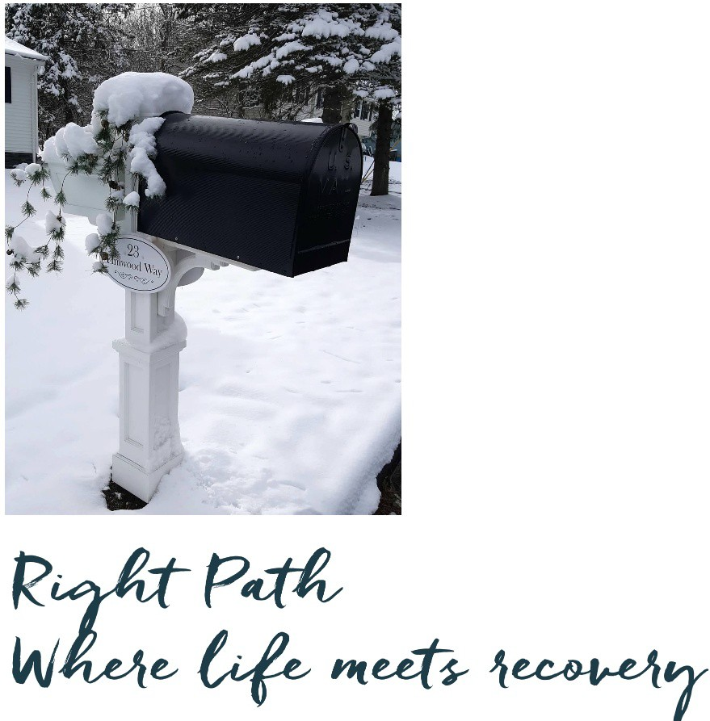

After rehab or extended care , we offer the sober living environment that sustains your new found balance and health.

We are a structured, trauma-informed sober living home (CCORR) with in-house workshops , art and equine therapy and "random fun activities". We offer you the opportunity to continue healing what addiction left in its wake so you can connect to sustainable recovery.
You'll be able to find the outpat ient therapy with a private practitioner (that take most insurances) and be active in self-help (12-Step, Refuge, SMART) meetings.

We invite our residents to create their best new life with fun, compassion and serious thought. Welcome home!

3

What a Day Looks Like

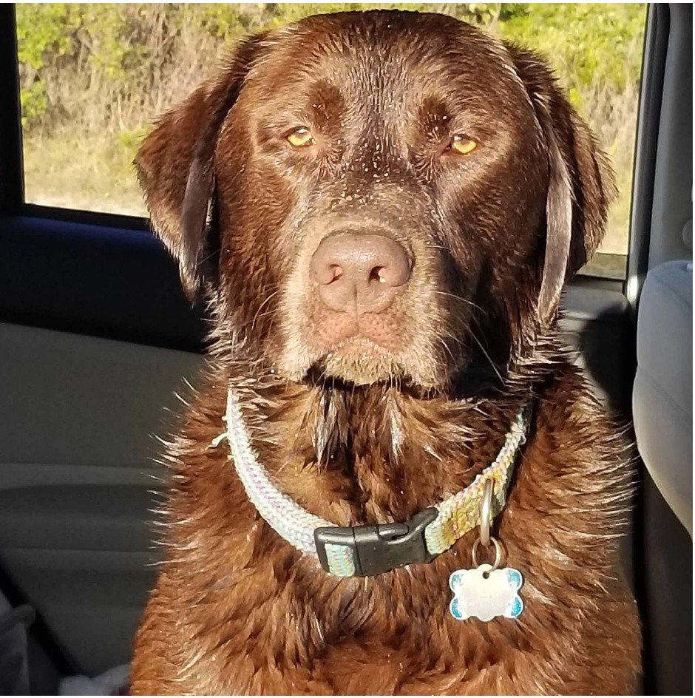

It's your life and no one else knows you like you. You might have become lost during your addiction and find that recovery is like meeting yourself again!
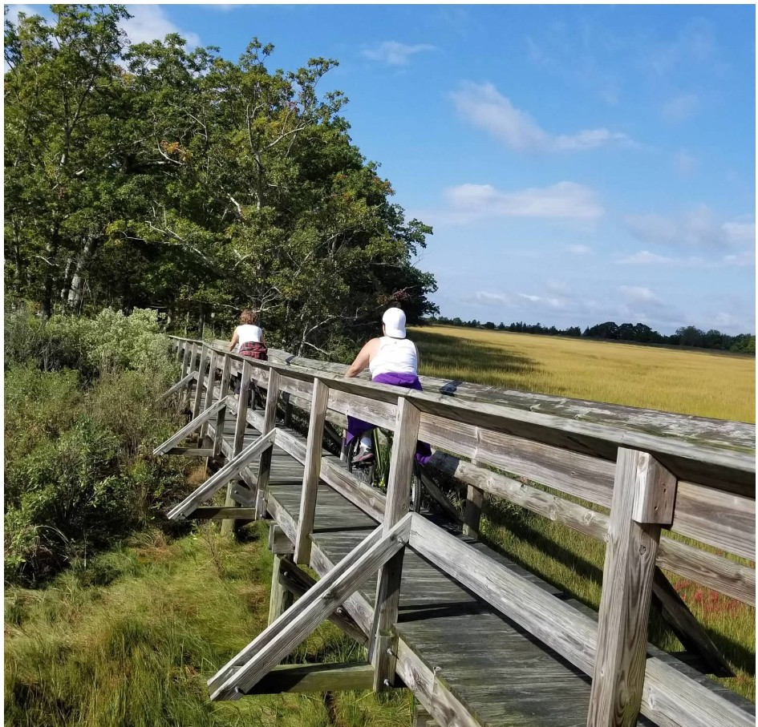
Because you'll be living your life like you never embraced it before, putting your recovery first may take some eff ort so we offer a team - in-house coach and a therapist of your choosing - to work closely with you. Basics include assistance coordinating meetings, t her ap y, soul work, workshops, meditation, family life, and finally, your purpose or passion-driven work or school.

It's as busy or as relaxing as you want it to be. Along the way, we offer experiences in hiking, biking on some of the most beautiful natural resources Connecticut has to offer. Gym and yoga studio membership s are included.

Everyone needs some "chill" time too. Find your spot in the yard or in the house or down at one of

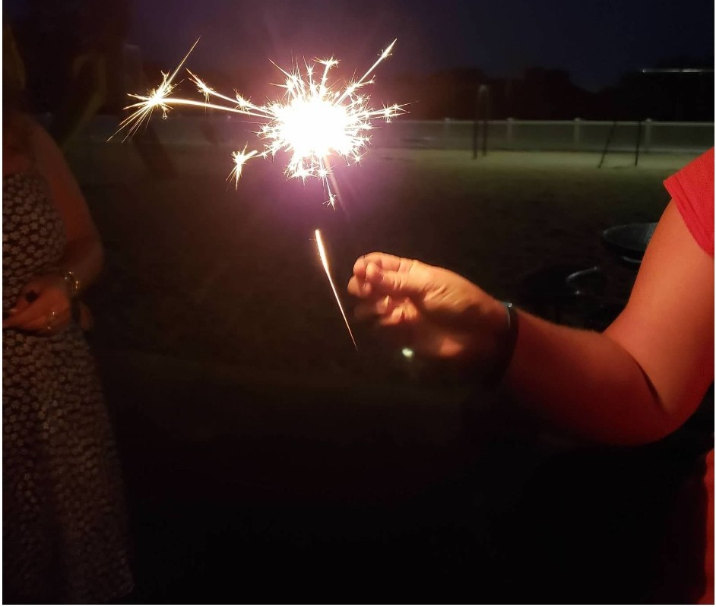
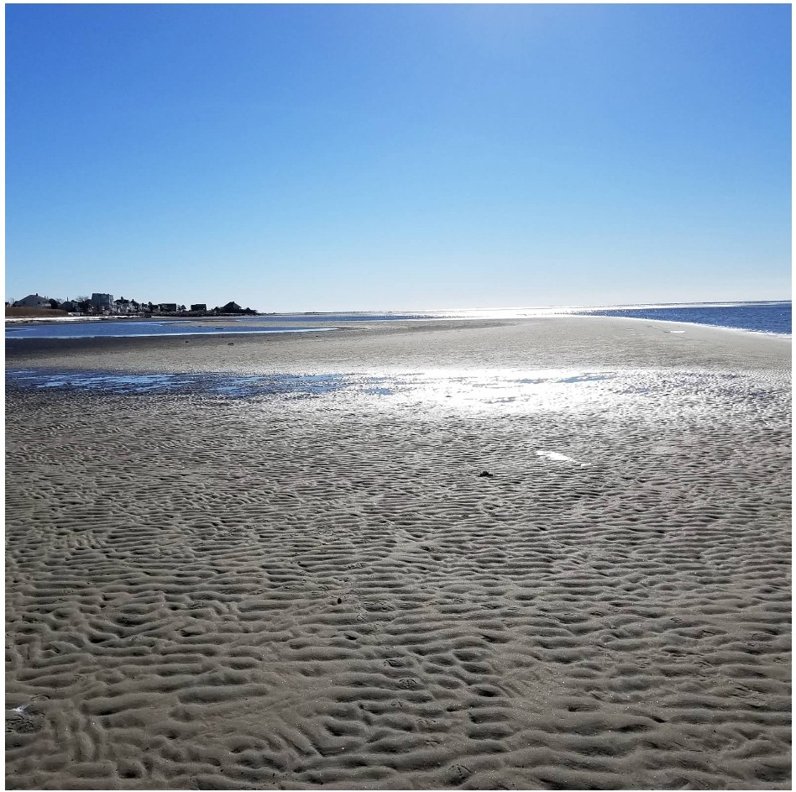
Located one mile from Long Island Sound, Right Path in Clinton is for women only. We're in a safe neighborhood with the kind of neighbors that bake pies for each other and share their garden's vegetables every summer. f=or those without a car, you can get around on foot, Uber or on our bikes.
One mile to Clinton Beach. f=our miles to Hammonasett Park. 15 minutes to Chatfield Hollow Park. Two miles to grocery shopping. Two miles to the Clint on Crossing Mall. Three miles to a full-service gym with a sauna. Three miles to the Clinton train station. 15 minutes to riding lessons or the
Sound Retreat.
20 minutes to zip lining. 30-minute train to New Haven or New London. If driving: one hour to Providence, two and a half hours to Manhattan or three hours to Boston.

Surrounded by AA and NA 12-step meetings, we are also 20 minutes to SMART Recovery, Refuge Recovery, and Buddhist Recovery.

We align with intensive outpatient providers (IO P), Project Courage and Recovery Services of Connecticut, and three other single focus IOP ser vices: addiction with a secondary diagnosis (DBT), eating disorders or LBGTQ recovery. We assist residents and continuing care providers in making appointments that follow the clinical recommendations. We have been here long enough to know the area's most effective private practitioners in CBT, Neurofeedback, and t:tv1DR,
psychotherapists, psychiatrists, general practitioners, advanced practice registered nurses, and specialists in t:D and family systems. Each resident is urged to find the therapist(s) that work(s) best for them.

We support Vivitrol, Sublacade, or Naltrexone and will accept Suboxone when a taper is planned. We use a self-key locker system to hold medication and oversee medication distribution when requested.

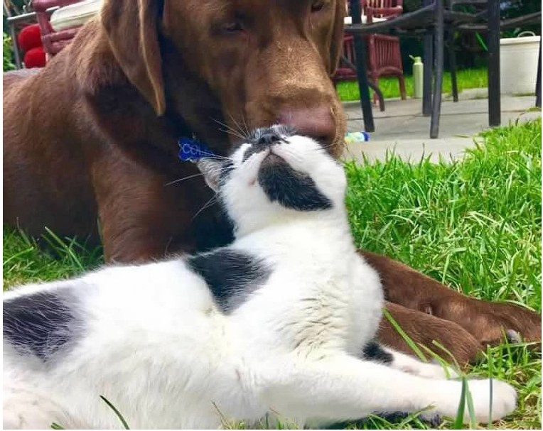

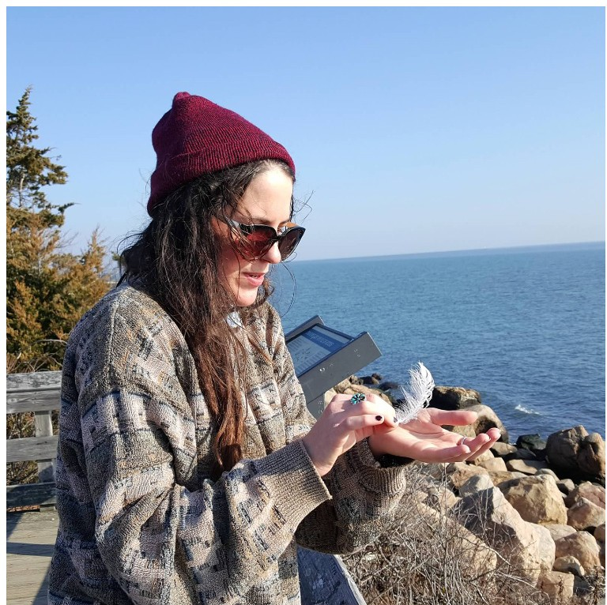
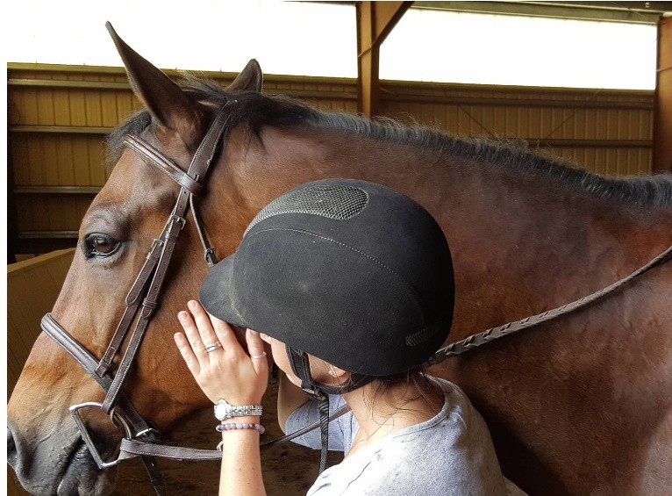
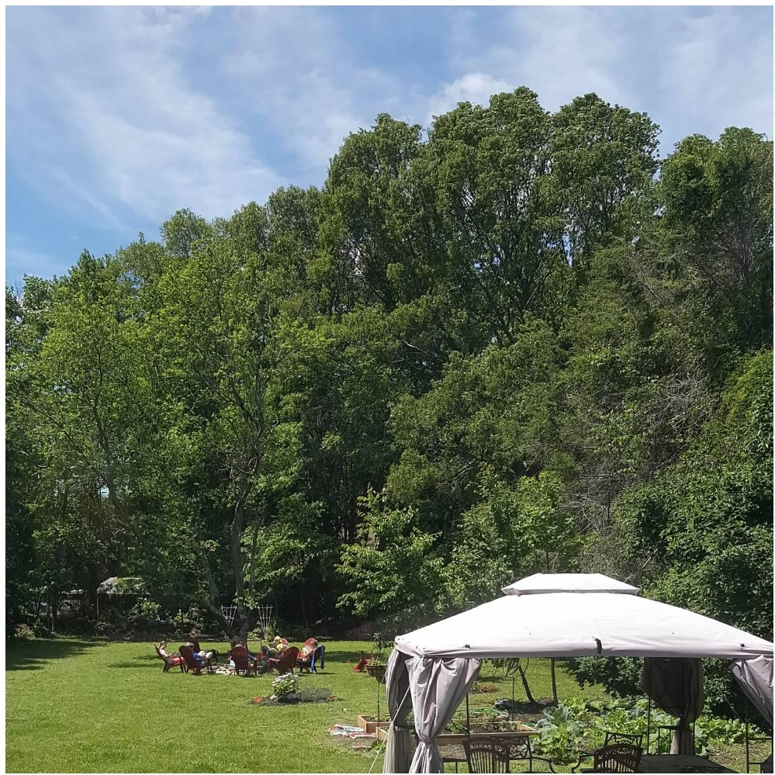
Our coaches are highly trained and Connecticut certified. Working closely with resident s, they form the backbone of our houses. They are dedicated to our residents one to one and serve with a set of strict, binding ethics.

ACCOUNTABILITY: Offers one to one accountability for meeting goals in recovery and wellness. Performs room and chore check-ins, testing/ screening.

ORGANIZING and SCHEDULING: the shared house
dinners, chores, recreation, in-house workshops meetings, work , wellness, and family life.

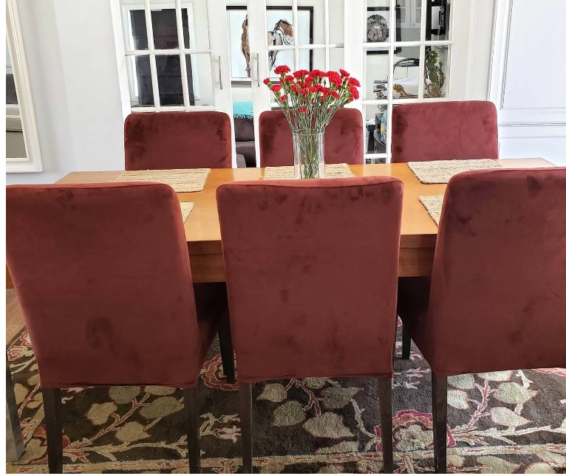

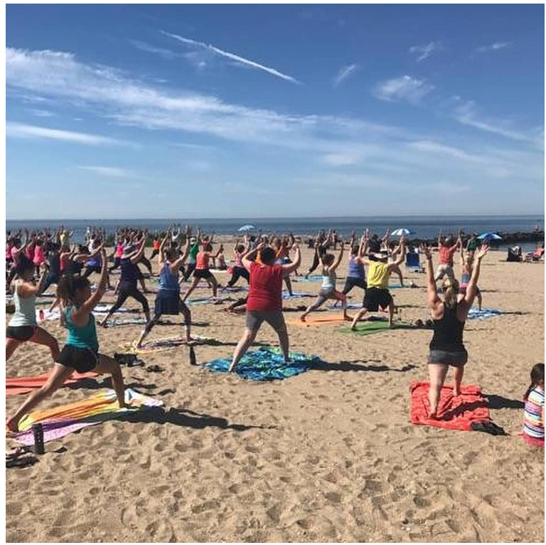
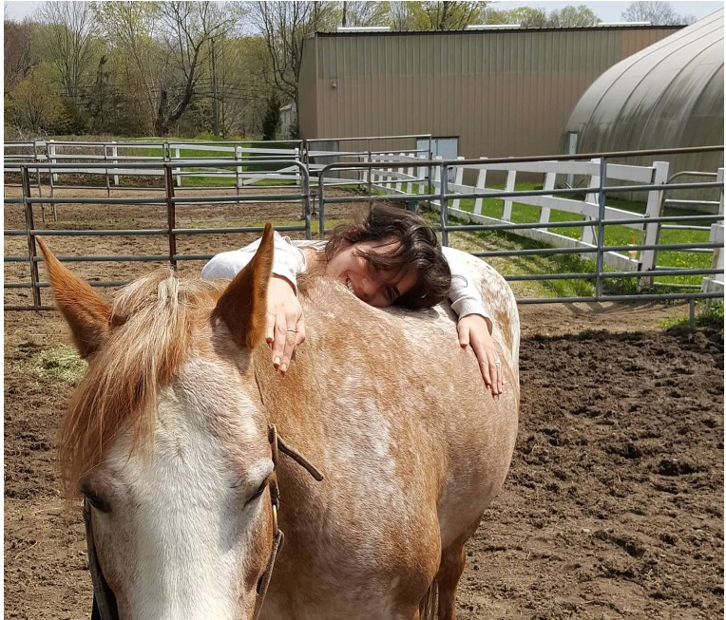
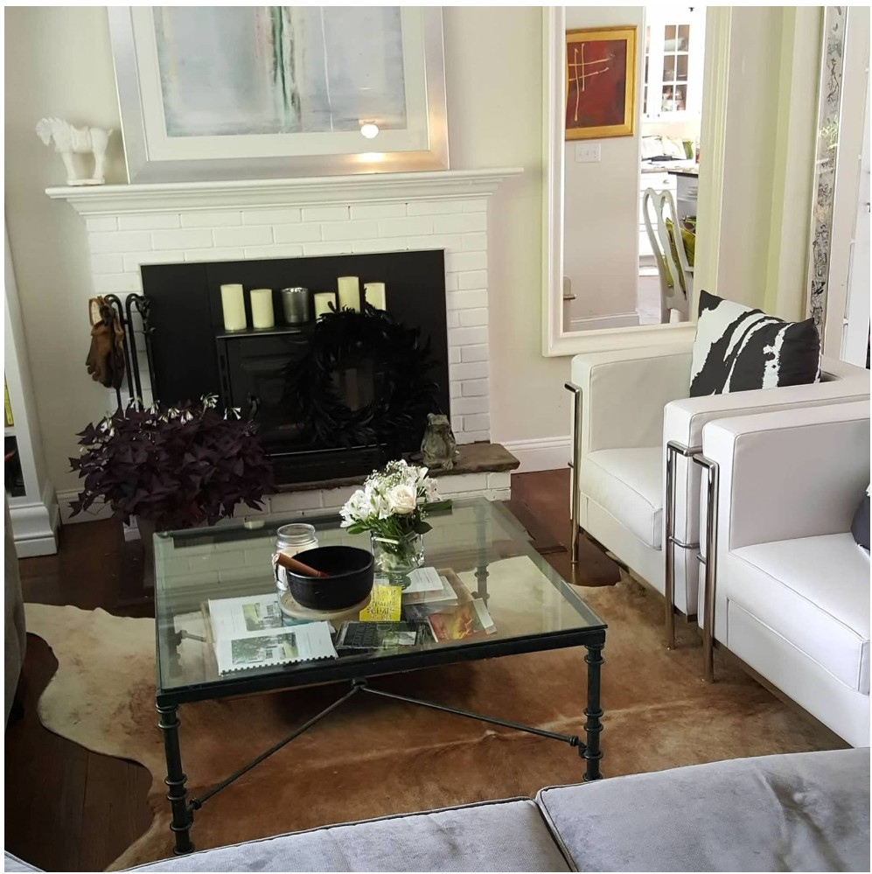
LEADS: 12-step/refuge workshop and monitors step work. tv1onitors the temperature of our environment and uses bonding exercises to welcome newcomers.

LIAISON: acting between resident and family, therapists and referring facility.

TR ANSPO RTAT I O N:: fills you in on our area's services and makes escorted transportation available at a small fee.

TECHNOLOGY: sets up and monitors Life 360,
Trulink cards and Oathtrack .

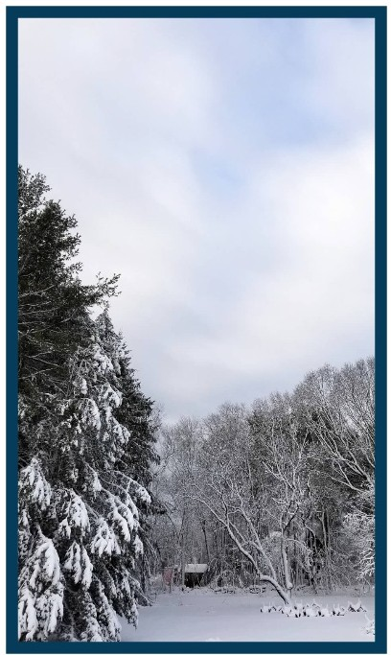

With coaching and workshop participation, residents rebuild a life. Recognizing that thinking patterns change in recovery, Right Path offers many ways to explore your mind and learn how and what it thinks.

12-STEP OR REFUGE RECOVERY MEETINGS and WORKSHOPS

RESPONSIBLE COMMUNITY LIVING SHARING EVENING MEALS TOGETHER
EQUINE EFFECT and ART EXPERIENTIALS
ADDICTION, DBT, EMDR, CBT THERAPY
COACHlNG SUPPORT FOR WORK, SCHOOL OR VOLUNTEERING

what we do differently:
The Fourth Step Turnabout Refuge Recovery Mindfulness
The Evolution of Self -Lo ve Workshop

11

Hi Lisa,

It is Marianne, Maggie's mom. Just wanted to share a picture from Maggie's 31st birthday. Words can never express the gratitude that Tom and I feel for having fallen into your loving care. Maggie is doing really well and getting better and stronger every day. She just started school-still at CSU. Thank you for teaching us how to have a relationship with our daughter.

Love you, Marianne

Getting physically active and eating right literally results in feeling the natural rewards of dopamine while also being invigorated with more self-awareness and a deeper understanding of empowerment. The rewards of connection and friendship are a natural result of our house's activities.

TAKE TURNS PLANNING AND PREPARING Tl-IE EVENING MEALS using whole foods
Tl-IE ROPES AT JORDAN'S. (A chance to play and to be present, a sign of real surrender and
trust of each other. ) RIDING LESSONS. or the serious show jumper rider to the raw beginner at Westbrook Hunt
Club. GYM /YOGA STUDIO MEMBERS -IIP. Open gym with 75 classes per week and a sauna. Tl-IE NATURE BATH. I-liking and biking on paved trails at the beach and in the woods.
KICK BOXING. To empower, engage and allow healthy aggression in women. KAYAKING/SAILING. We are in a coastal area that has numerous rivers. SKIING. We ski in New 1-lampshire nearly every weekend.
BIKING at 1-lammonasett or Chatfield

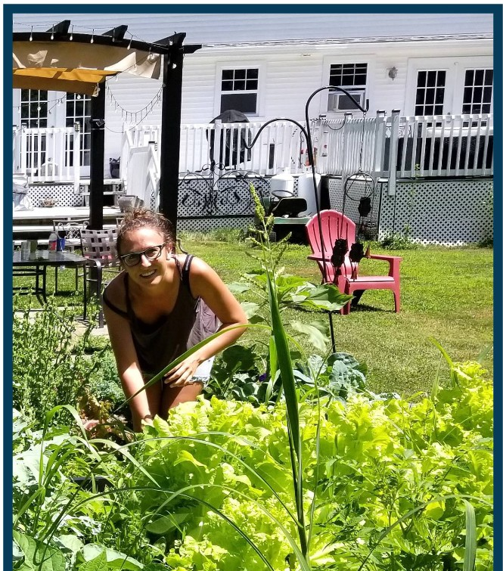
What we do differently
Bicycles always available House members direct recreational activities and evening meals

Recovery allows us the chance to grow again. As our disease had progressed, we had sought more alone time. Now, to grow, we need to belong to something. Soul work is the pivot point for many who enter long term recovery. We offer meditation practice at the beginning of our meetings. Becoming present is one of the best ways we know to become mindful and know your soulful self.

Addressing "soul" in terms of recovery means examining your attitude toward life and deciding "how" to use the talents that you have. It's honoring a set of values that help you determine where you belong in this world. What does a maturing adult look like in your world?

12-STEP/REFUGE RECOVERY MEETINGS
GARDENING
MINDFULNESS WORKSHOPS
YOGA
SOUND RETREAT MEDITATION
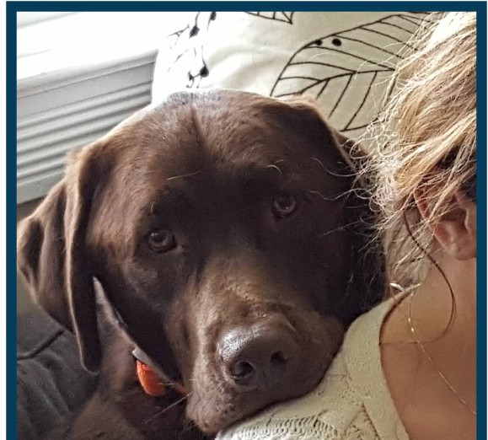
12STEP
CONSCIOUSNESS
CERAMICS
VISIT BILL WILSON AND STEPPING STONES
RECOVERY COMMUNITY CONSCIOUSNESS
ENERGY HEALING (reiki, shaman, massage)
WORKSHOPS IN EXPLORING VALUES

what we do differently:

Workshops Sound Retreat

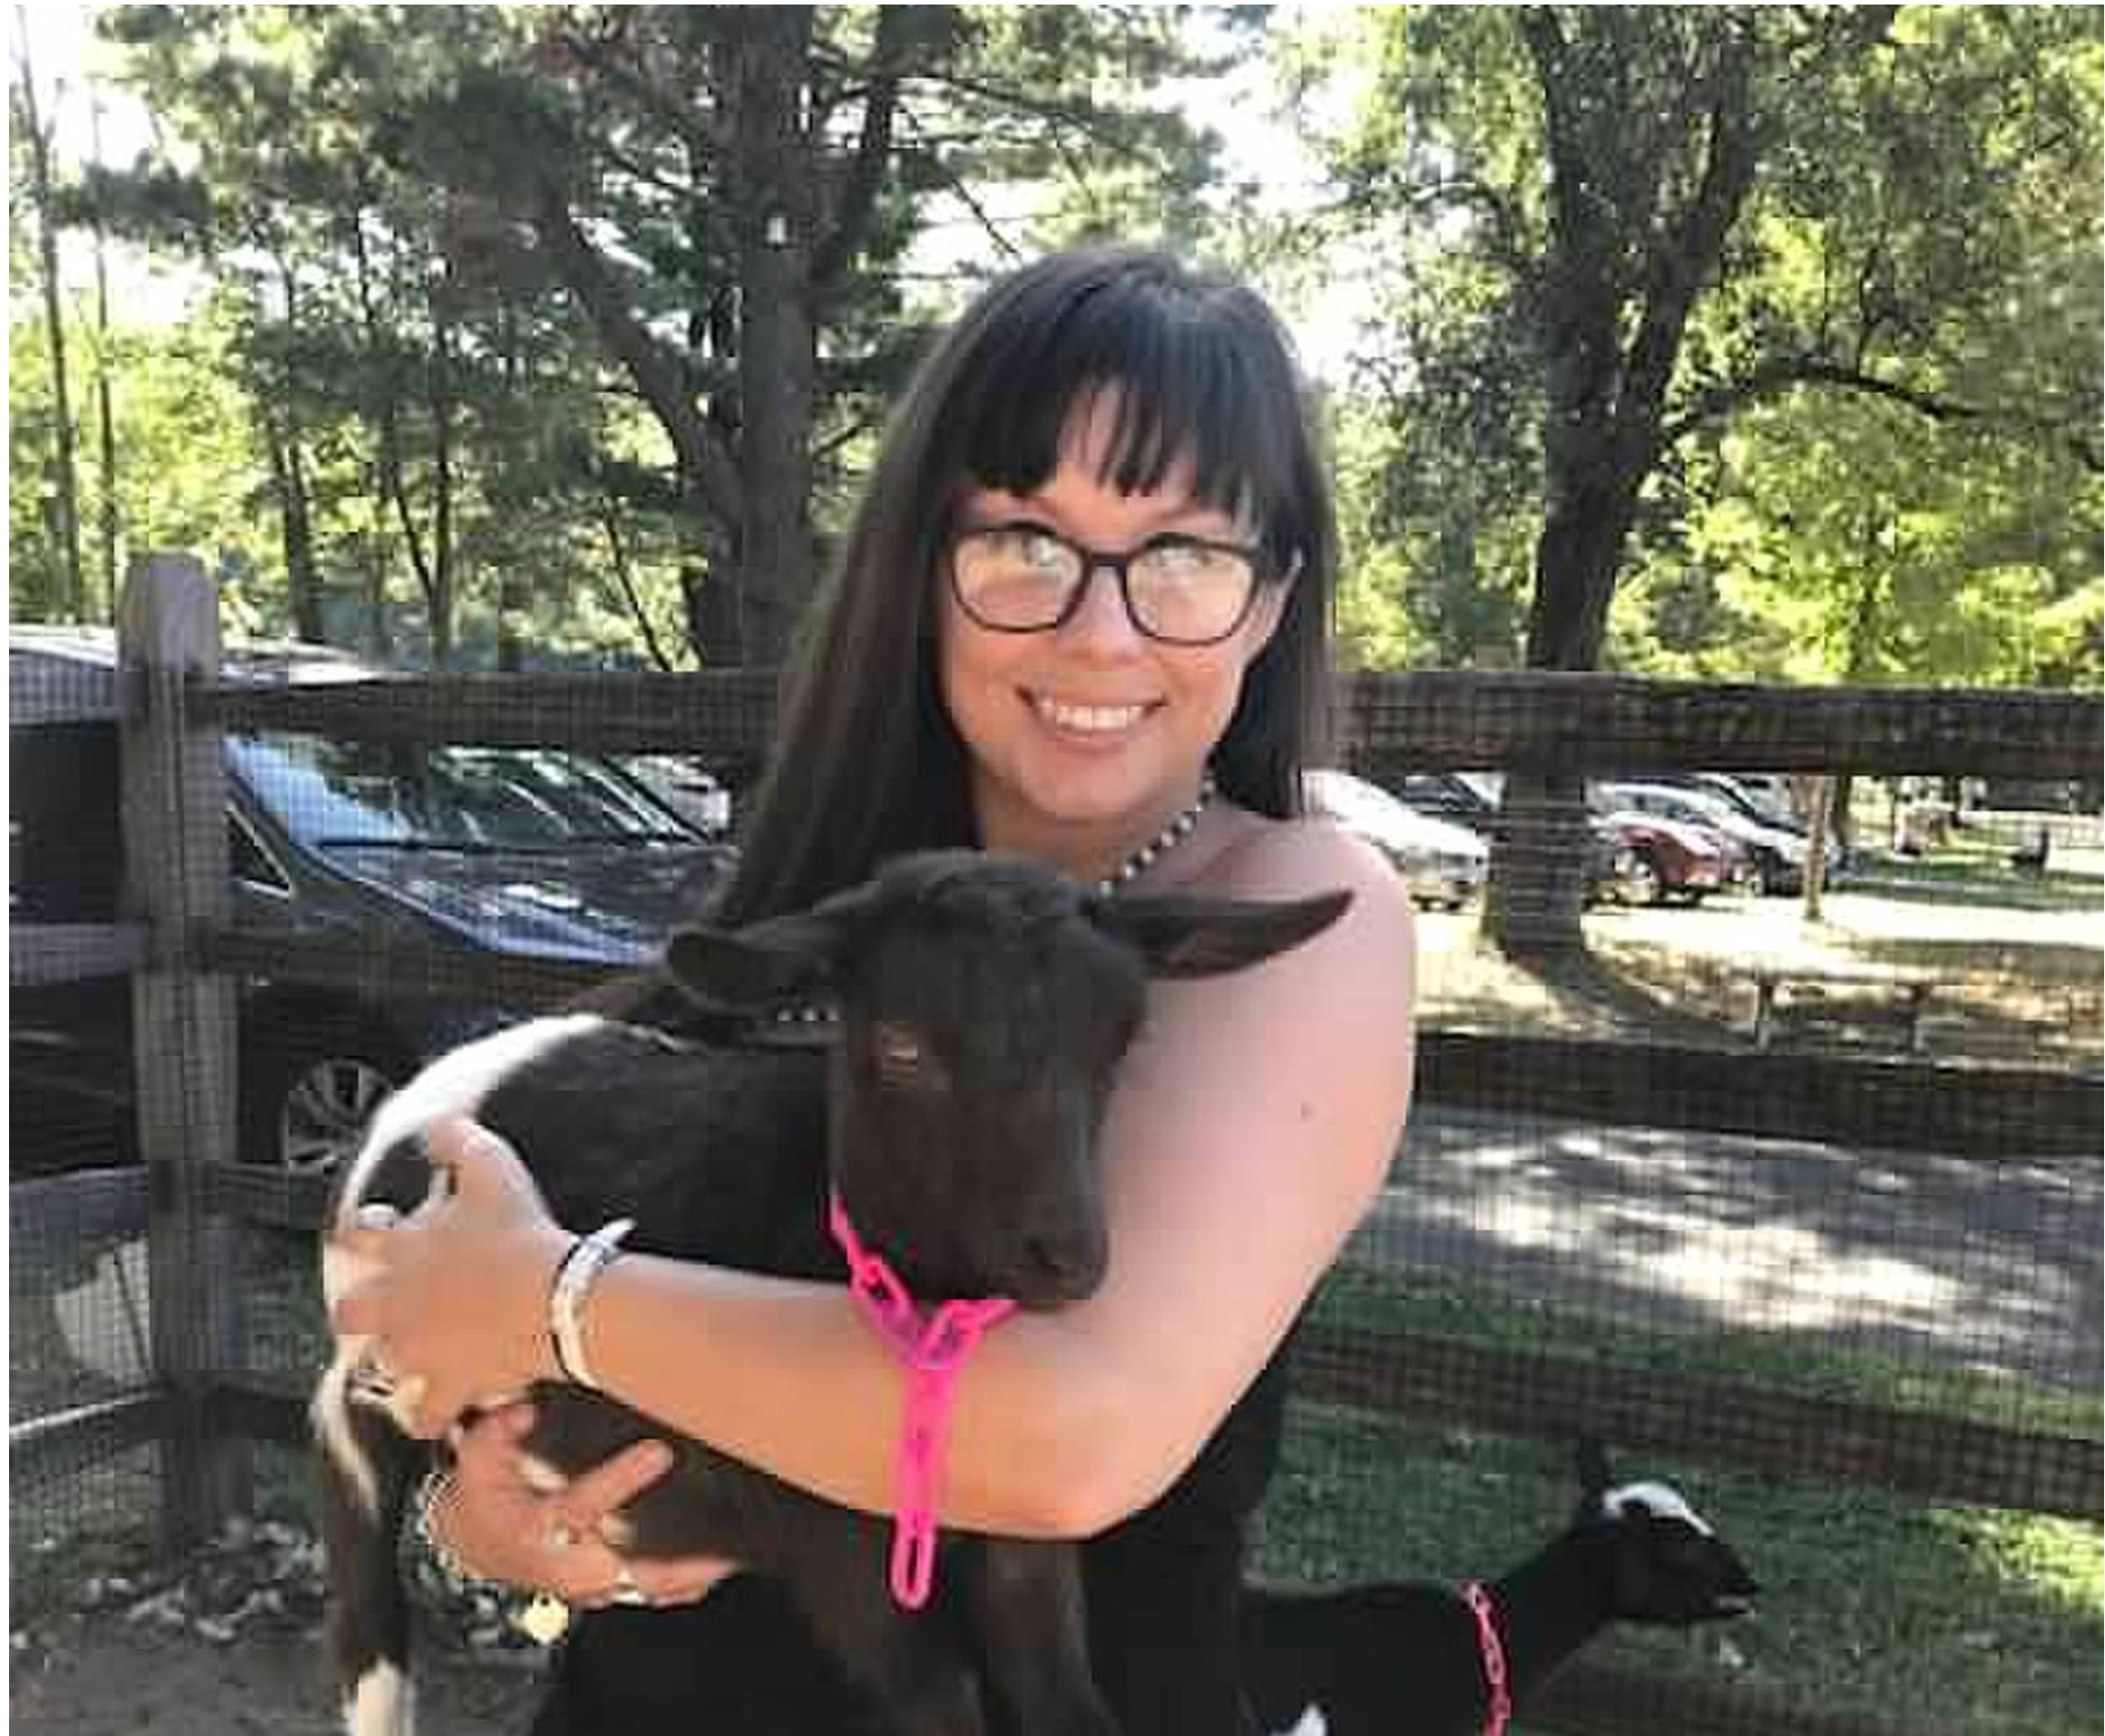

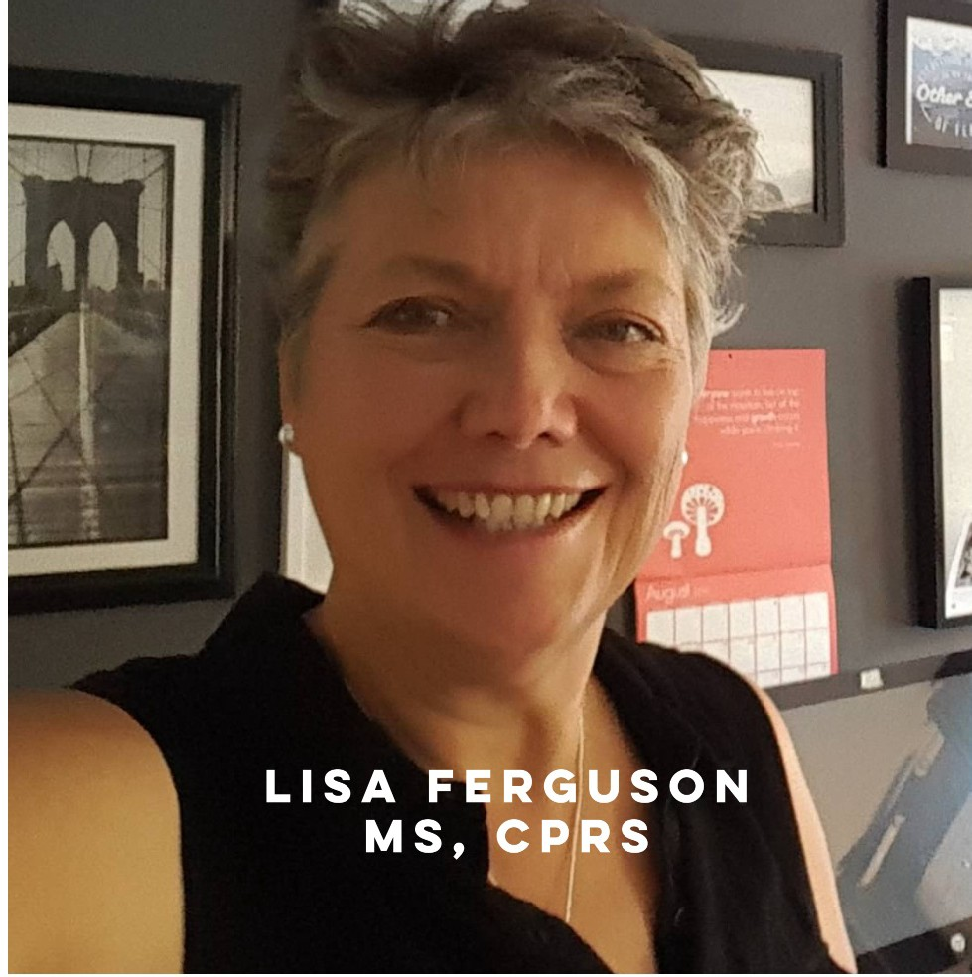Please call a member of our staff for a simple and seamless phone interview and appointment for a family tour.

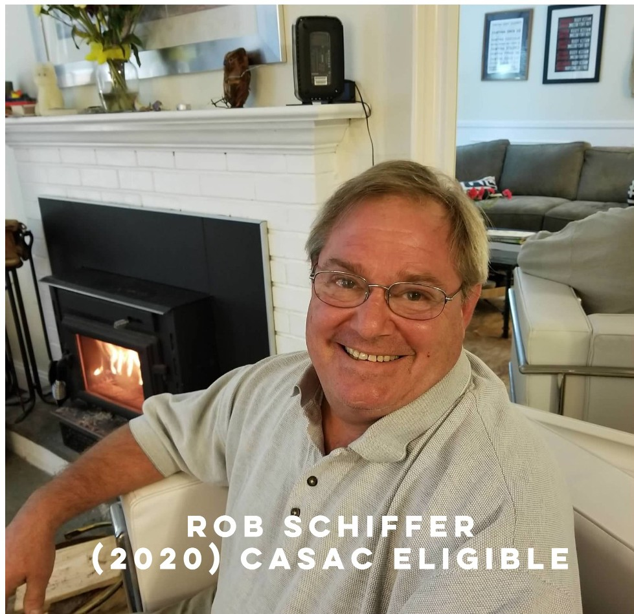Pricing (flexible when necessary) is per 28 days; singles and doubles are available. Our fee includes coaching toward becoming your own case manager, gym membership, yoga, art and equine therapy, and workshops in12-step and refuge recovery.Expect to be able to use insurance for therapy and private pay for housing, food and transportation. Rides, food and recreation are available at nominal cost.
Residents are expected to participate in recreation.

Rob Schiffer at 203-980-7042 Lisa Ferguson at 203-339-1191

OFFICE : 860 -552-4847

16

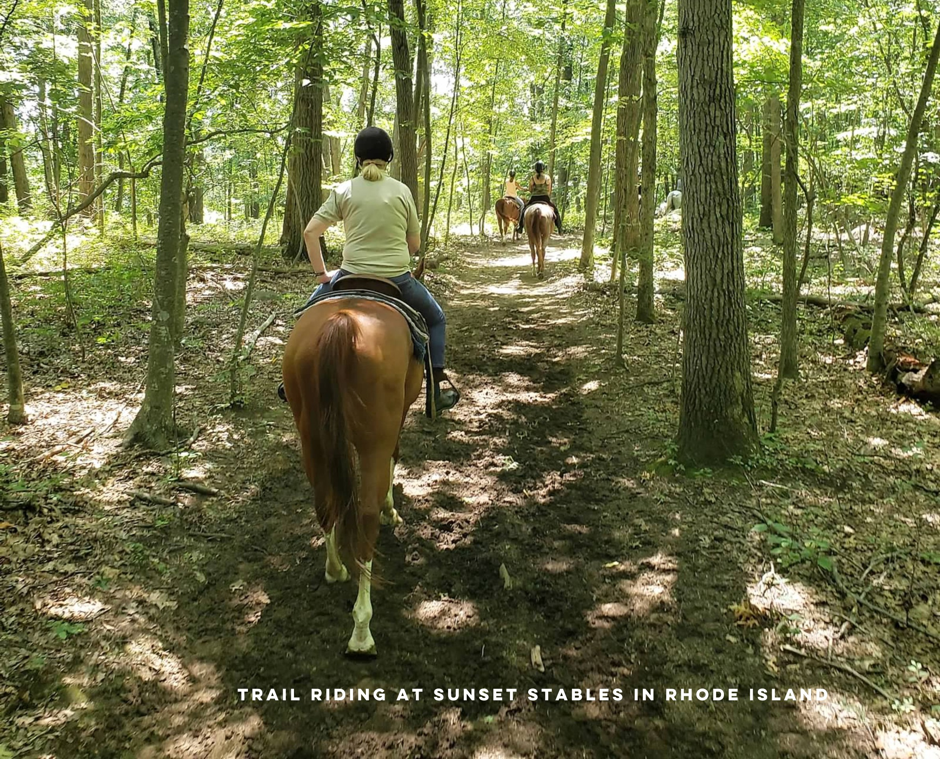

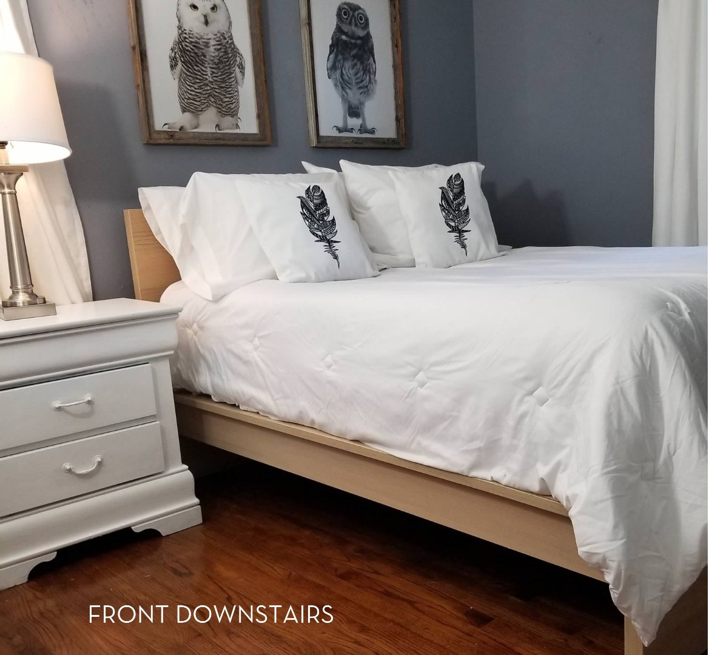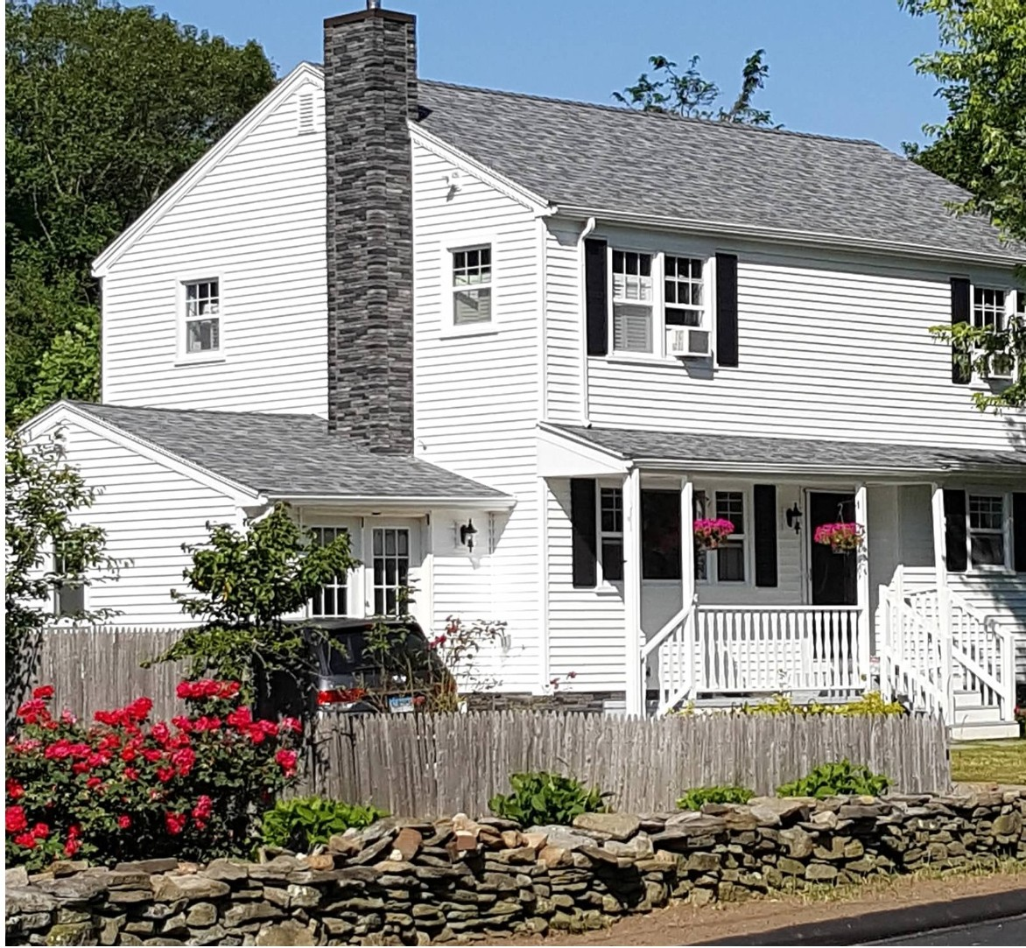

Our mission continues the recovery journey began in a 30 or 90 day program with a structured and loving home with like-minded people and a live-in recovery coach. Decades of research urge that after rehab and/or extended care, sober living is the next logical step toward recovery life. Direct from SAMf-1SA research, we offer the four pillars of recovery: (1) community, (meals, workshops and "random fun activities") (2) wellness, including membership at the gym and yoga studio/healthy meals, and coaching support to attend therapy (3) purpose in work or school and (4) structure in the home; especially when re-integrating into a family dynamic or a new home.

We welcome those with or without a history of treatment.

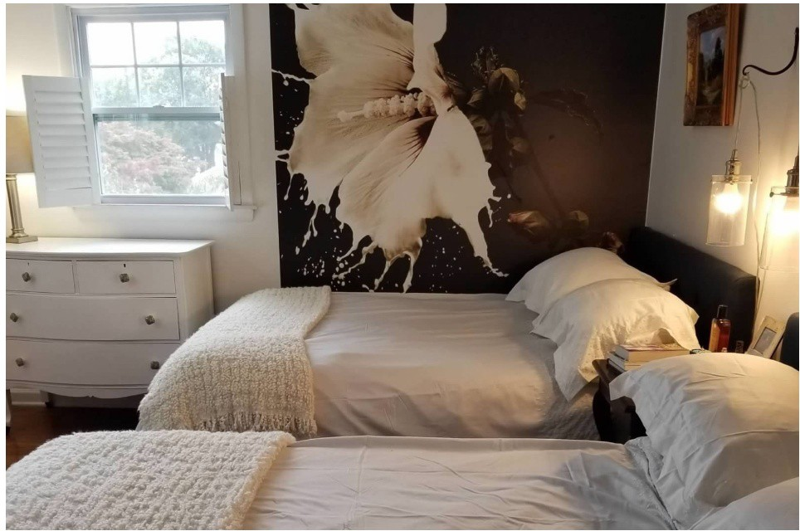
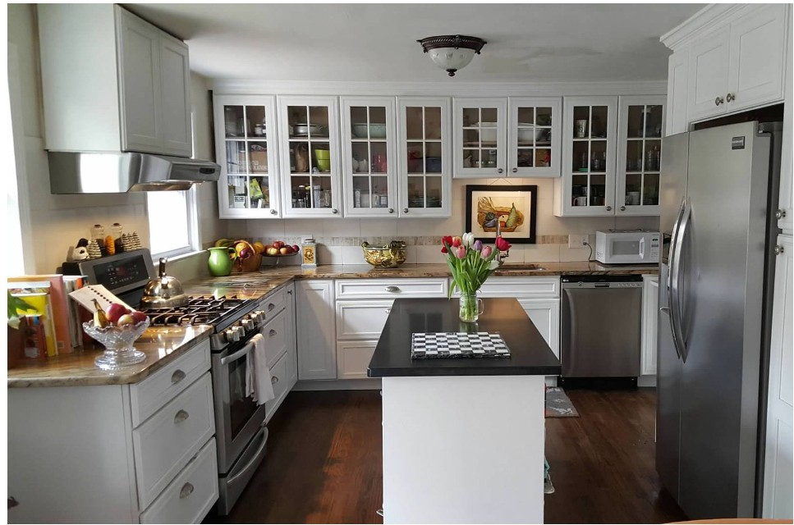
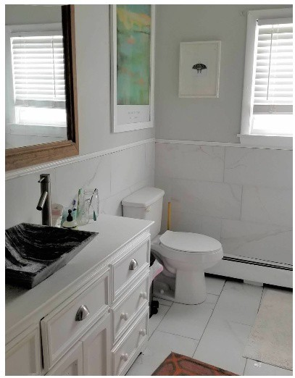
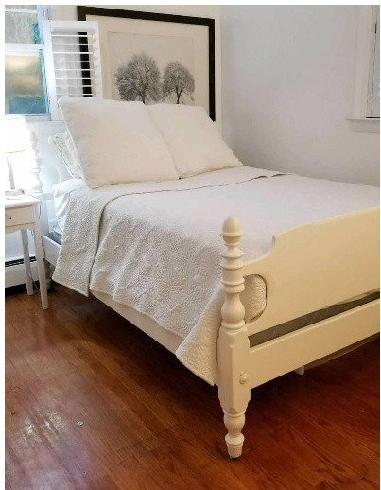
FRONT UPSTAIRS DOUBLE

Four private rooms and two double rooms with pillow-topped beds. Three full baths. Fully equipped chef's kitchen. Grills on deck, organic garden and fire pit. Dog and cat.

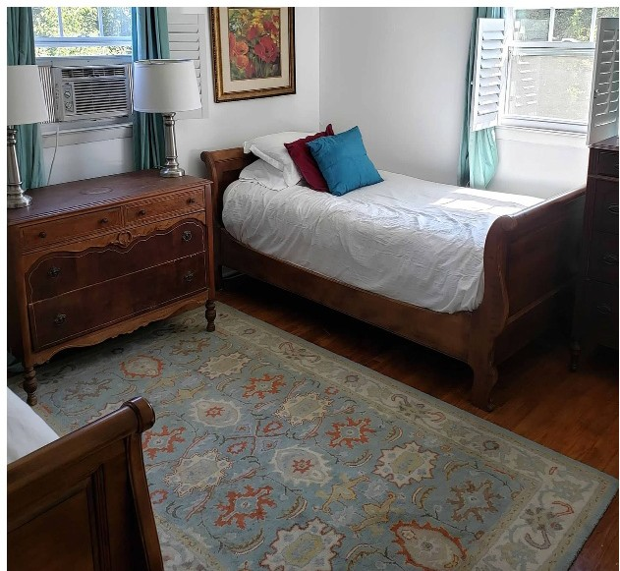
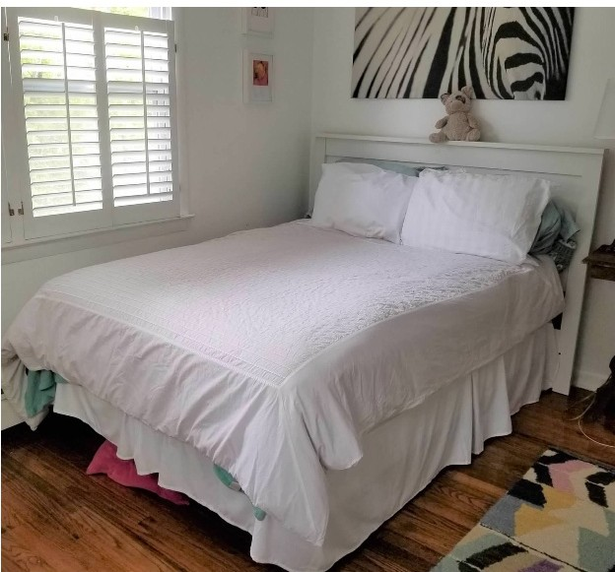
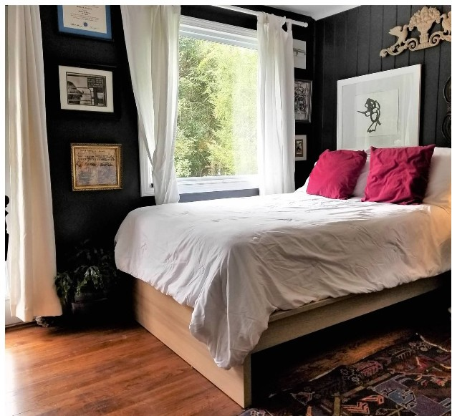
BACK UPSTAlRS DOUBLE FRONT UPSTAIRS SINGLE BACK DOWNSTAIRS SINGLE

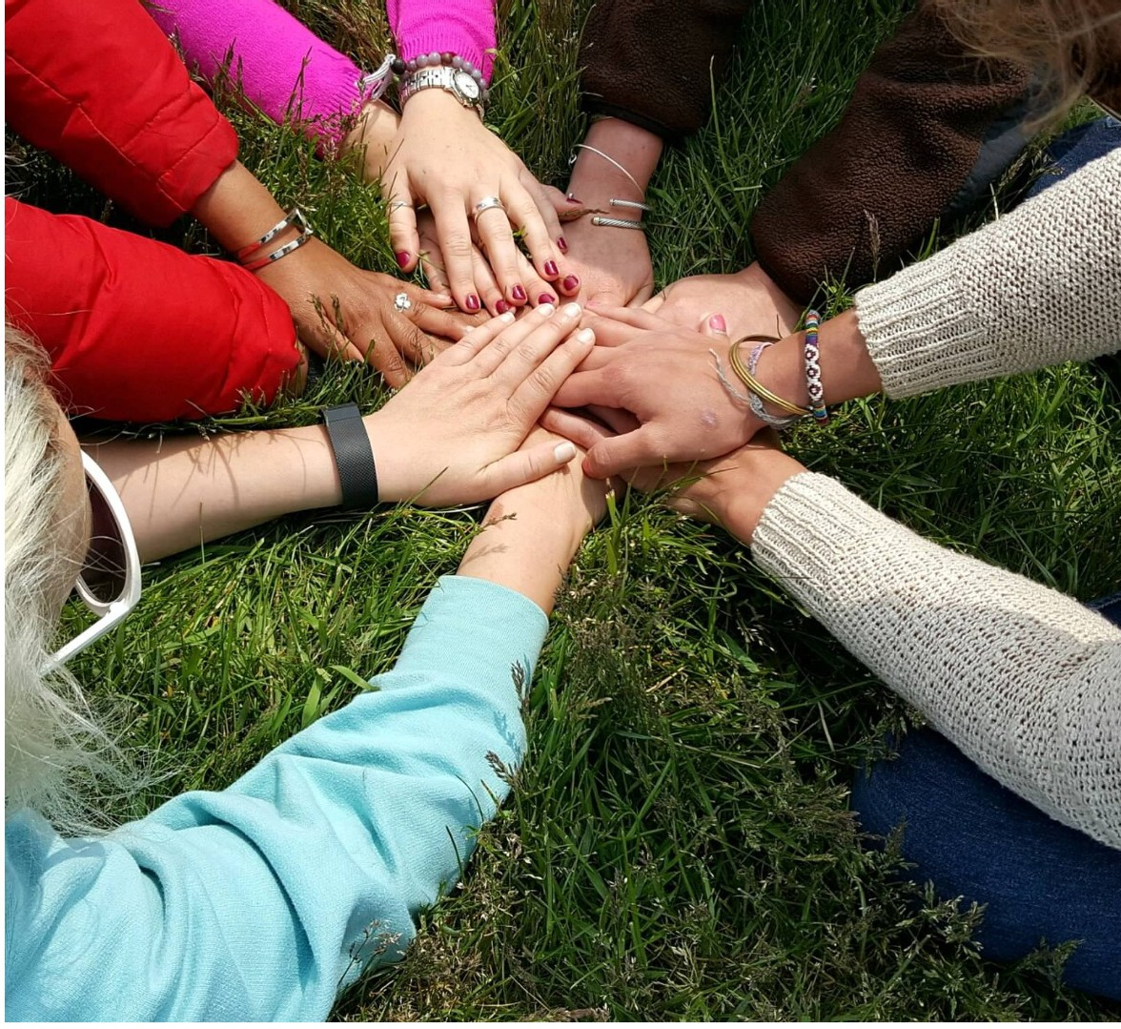
Geared toward an ethic of "grow in recovery while you work, play, and eat", there are plenty of opportunities to work or return to school.

COLLEGES
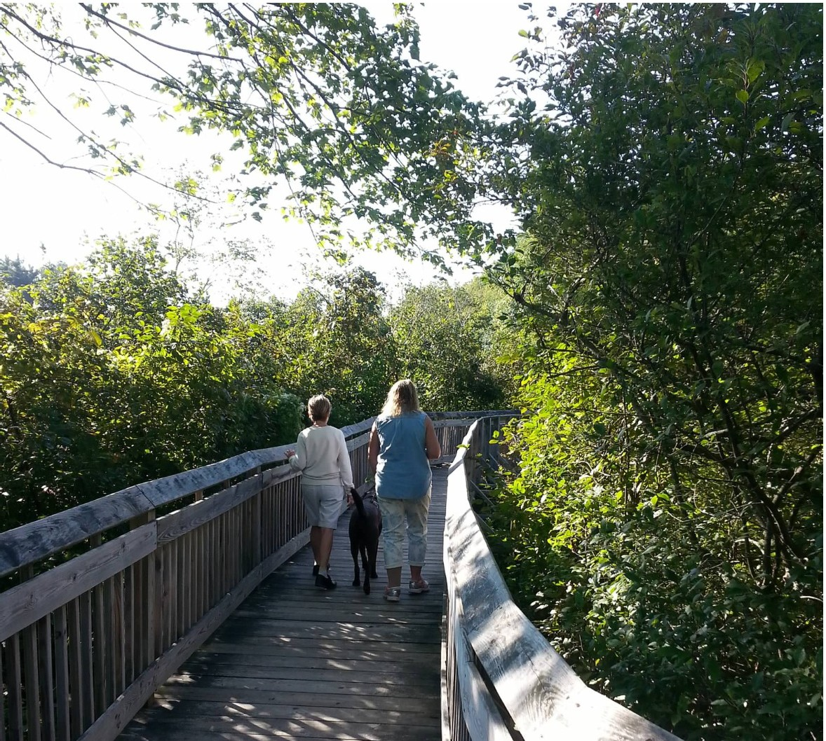
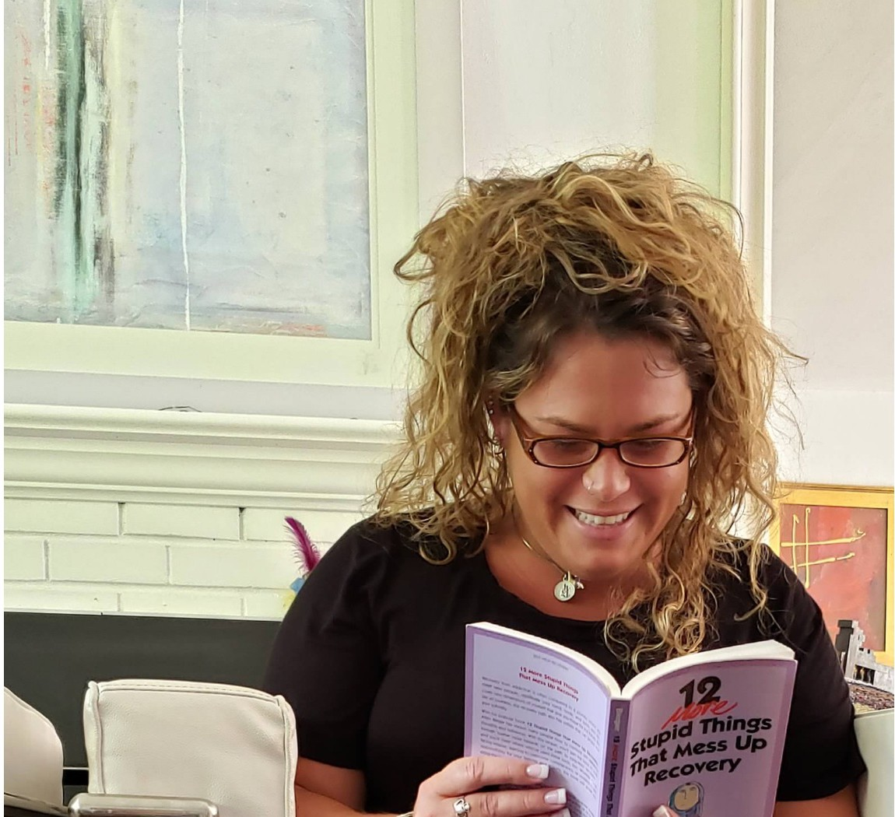
New Haven , Middletown and New London are home to three community colleges­ Gateway, Middlesex and Three Oaks, while Yale, Albertus Magnus, Southern are within 30 minutes.

